**List of Questions**

1. **List the Movie/TV Series along with the Female Movie Star acted in that movie/tv series where Genre Category is "Family".**

select m.Name, m.Type, concat(rtrim(s.StarFirstName),concat(' ',ltrim(s.StarLastName))) as StarName

from MovieOrTV as m

inner join StarMovie as sm

on m.MovieORTVID = sm.MovieORTVID

inner join Star as s

on sm.StarID = s.StarID

inner join GenreMovie as gm

on m.MovieORTVID = gm.MovieORTVID

inner join Genre as g

on gm.GenreID = g.GenreID

where g.GenreCategoryName like '%Family%'

and s.Gender = 'F';



1. **List the TV Series and the total number of awards won by that TV Series.**

select m.Name, count(*) as TotalAwards, rank() OVER (ORDER BY count(*) DESC) AS Rank

from MovieOrTV as m

inner join AwardHeader as ah

on m.MovieORTVID = ah.MovieORTVID

inner join AwardCategory as ac

on ah.AwardHeaderID = ac.AwardHeaderID

inner join AwardDetails as ad

on ac.AwardCategoryID = ad.AwardCategoryID and ac.AwardHeaderID = ad.AwardHeaderID

where ad.Status = 'Won' and m.Type = 'TV'

group by m.Name;

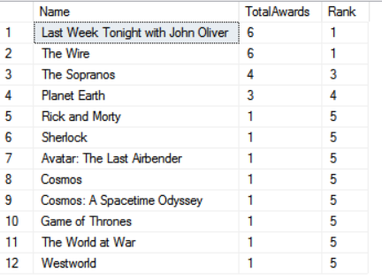

1. **Give me a list of movie names with highest gross collection for each genre also calculate Total Revenue. Make sure the status is 'Nominated' for those movies.**

SELECT genre.GenreCategoryName, SUM(movieOrTV.GrossCollection) AS Revenue

FROM MovieOrTV movieOrTV

INNER JOIN GenreMovie genreMovie

ON movieOrTV.MovieORTVID = genreMovie.MovieORTVID

INNER JOIN Genre genre

ON genreMovie.GenreID = genre.GenreID

INNER JOIN AwardHeader awardHeader

ON movieOrTV.MovieORTVID = awardHeader.MovieORTVID

INNER JOIN AwardCategory awardCategory

ON awardHeader.AwardHeaderID = awardCategory.AwardHeaderID

INNER JOIN AwardDetails awardDetails

ON awardCategory.AwardCategoryID = awardDetails.AwardCategoryID

WHERE awardDetails.Status LIKE '%Nominate%' and movieOrTV.Type = 'Movie'

GROUP BY rollup(genre.GenreCategoryName)

ORDER BY genre.GenreCategoryName;

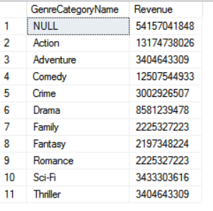

1. **List the movies with total number of tickets sold. Rank in descending order.**

SELECT M.Name AS "Movie Name" , Sum(T.NoOfSeatsBooked) AS "TotalTicketSold"

FROM MovieORTV AS M

INNER JOIN MovieTheatre AS MT

ON M.MovieORTVID = MT.MovieORTVID

INNER JOIN Theatre AS TH

ON MT.TheatreID = TH.TheatreID

INNER JOIN ShowTimes AS ST

ON TH.TheatreID = ST.TheatreID

INNER JOIN Tickets T

ON ST.ShowTimesID = T.ShowTimesID and ST.TheatreID = T.TheatreID

group by M.Name

ORDER BY TotalTicketSold desc;



1. **Give me the list of movies with highest rating 1 year after the release date.**

WITH CTE AS(

SELECT genre.GenreCategoryName GenreCategoryName, movieOrTV.Name Name, movieOrTV.Rating Rating,releaseDate.ReleaseDate ReleaseDate,

DATEPART(Year,DateAdd(Year,+1,releaseDate.ReleaseDate)) OneYearLater,

RANK ()OVER (PARTITION BY genre.GenreCategoryName order by movieOrTV.Rating DESC) AS RowNo

FROM MovieOrTV movieOrTV

INNER JOIN GenreMovie genreMovie

ON movieOrTV.MovieORTVID = genreMovie.MovieORTVID

INNER JOIN Genre genre

ON genreMovie.GenreID = genre.GenreID

INNER JOIN ReleaseDate releaseDate

ON movieOrTV.MovieORTVID = releaseDate.MovieORTVID

WHERE LEFT(releaseDate.ReleaseDate,4) <= DATEPART(Year,DateAdd(Year,+1,releaseDate.ReleaseDate))

GROUP BY genre.GenreCategoryName,movieOrTV.Name, movieOrTV.Rating,releaseDate.ReleaseDate

)

SELECT GenreCategoryName,Name,Rating,ReleaseDate,OneYearLater FROM CTE WHERE RowNo = 1;

